

**A**

**Project Report on**

***“ONLINE CAKE AND GIFT ORDER SYSTEM”***

***Submitted by***

**Mr. Jadhav Atul Vikas**

*T.Y.B.Sc (Computer Science)*

*Under the guidance of*

Prof. Anarase L.P.

In a partial fulfillment of the requirements of the degree of

B.Sc.(Computer Science)

Under

Savitribai Phule Pune University, Pune.

Dada Patil Mahavidyalaya Karjat, Ahmednagar.

Academic Year 2016-2017



**Dada Patil Mahavidyalaya, Karjat**

**Department of Computer Science**

***CERTIFICATE***

This is to certify that project entitled “***ONLINEE CAKE AND GIFT ORDER SYSTEM***” Submitted by “***Mr. Jadhav Atul Vikas***” students of T.Y.B.Sc (Computer Science) examination of Savitribai Phule Pune University, Pune during the academic year 2016-17. It is original work carried out under the supervision and guidance by **Miss. Gaware S.R** and under goes for the project.

**Date: /03/2017**

|  |  |
| --- | --- |
| **Project Guide**  ( Miss. Gaware S.R ***)*** | **Head of Department**  (Prof: Burte G.V.) |

|  |  |
| --- | --- |
| **Internal Examiner** | **External Examiner** |

***ACKOWLEDGMENT***

I wish to thank the opportunity to express our prefunds thanks & gratitude to all those who have directly helped us in the completion of this project.

The project titled ***“Online cake and gift order system”*** would not have completed without the valuable guidance and encouragement of Professors.

I am also extremely thankful to “Prof. Burte G.V.”, (Head of Department), “Miss. Gaware S.R.” and “Prof. Anarase L.P.” for their guidance and moral support.

I am also thankful to my colleagues for continuously inspiring us to complete this project.

Last but not least I express my deep sense of gratitude to my parents who have give me a plenteous of moral support and without whose invigoration and understanding it would not have been virtually possible for me to achieve this

success…….

**Yours Sincerely,**

Mr. Jadhav Atul Vikas

***INDEX***

|  |  |  |
| --- | --- | --- |
| Sr. No. | Name of Topic | Page No. |
| 1 | Introduction | 1 |
|  | 1.1 Introduction to System | 1 |
|  | 1.2 Scope of the System | 2 |
|  | 1.3 Existing System | 3 |
|  | 1.4 Proposed System | 4 |
| 2 | Analysis | 5 |
|  | 2.1 Feasibility Study | 5 |
|  | 2.2 Fact Finding Technique | 7 |
|  | 2.3 Hardware & Software  Requirement | 8 |
| 3 | System Design | 9 |
|  | 3.1 E-R Diagram | 9 |
|  | 3.2 Data Flow Diagram | 10 |
|  | 3.3 UML Diagrams | 14 |
|  | 3.4 Data Dictionary | 21 |
|  | 3.5 Form Design | 26 |
| 4 | Limitations | 57 |
| 5 | Feature Enhancement | 58 |
| 6 | Bibliography | 59 |

1. ***INTRODUCTION:-***

***1.1 Introduction to system:-***

To many people, the term “electronic commerce” means shopping on the part of the internet called the World Wide Web. Actually, electronic commerce (or e-commerce) also included activities like businesses trading with other businesses and internal processes that companies use to support their buying, hiring, planning and so on.

The project is aimed at developing a web application that describe the online shopping of cake and gifts. Online shopping is the one of the application to improve the marketing company product.

Cake and gift order system aims to accelerate customer orders. The main principle behind the need of cake and gift order system is easy to understand the menu and some links. It’s has user friendly and modular approach. The modular approach of the software increases the flexibility of the software. Date storing is easier. Paper word is the reduced. The record of each customer is stored that is customer’s name, contact details and some other information.

1

***1.2 SCOP OF THE SYSTEM:-***

1. Users can order the cake and gift without visiting the bakery or sweet hotels.
2. Users from any location can order the cake and gift by looking at the cake and gift items and pay in advance or at the time of delivery.
3. Save users time.
4. The online cake and gift order system will be helpful for the bakery or sweet hotels to increase the scope of the business by helping users to give order through online.
5. The main aim’s is to simplify and improve the efficiency of the ordering process for both customer and bakery or sweet hotels, **“Excellent client** **service”**.

2

***1.3 EXISTING SYSTEM:-***

* Reports are prepared manually as and when needed maintain of reports is very tedious task.
* In the existing system all transaction dealing of products purchasing of products were manually which is time consuming.
* To buy are product’s user has to collects information either by visiting the shop or asking which is the better one.

3

***1.4 PROPOSED SYSTEM:-***

* Shop online is the online application which provides the online shopping facility available for everyone.
* Shop online application concentrates more on user friendly interface and promotes. User to purchase faster and easier.
* Security issue pay’s major important today extra attention to word’s security is done in shopping applications.
* It Provide the customer support page.

4

***2) Analysis:-***

***2.1 Feasibility Study:-***

Feasibility is the process of planning to develop system or improving an existing system. The purpose of feasibility study is to develop a selection criterion, a selection procedure and effective decision making organization such company can be certain. It is working on right problem and in the right sequence.

Depending on the result of the initial investigation, the survey is expanded to a more detailed feasibility study.

**Technical Feasibility:-**

In technical feasibility, the user can write, read and can change stored data and proposal may be technically feasible. In this we can work for the project is done with current equipment. Existing software technology and available personal, if new technology is required what is the like hood that it can be developed.

**Economical Feasibility:-**

In Economical feasibility, economically the software cost less and there are more gains by using the computer system, because the other extra resources are not required like scanner, printer etc.

There are sufficient benefits in creating the system to make the cost acceptable.

5

**Operational feasibility:-**

Operational feasibility means considering whether it is feasibility to operate the system is our organization environment.

In operational feasibility, the interaction with software is very user friendly and accessing speed is faster.

6

***2.2 Fact Finding Technique:-***

To study the system we need to collect facts i.e. gathering information about the system. The proper use of tools for gathering information is the key to success analysis.

We used the following Fact Finding Technique:

* Observation

**Observation:-**

Observation allows analyst to gain information they can’t from any other fact-finding techniques. In this method analyst observes the flow of documents, way the process is carried out etc.

7

*2.3 Software & Hardware Requirement:-*

To run system it requires the following Operating System Environment.

Machine capability:-

Processor: Intel Core i3 and above

RAM: 4GB

Hard Disk: 500GB

Software required:-

PHP

My SQL

8

***3 System Design:-***

***3.1 ER-DIAGRAM:-***

Feedback

M M

Show

Can

Maintain

1

Order

Can

User

M M M

M 1

Taken

by

1

Admin

1

1

COD

Pay’s

Give details

M

Distributer

M

M

9

***3.2 DATA FLOW DAIGRAM:-***



10

First level DFD [ level 1.0 ]



11

Second level DFD [ level 2.0 ]



12

Third level DFD [ level 3.0 ]



13

***3.3 UML DIAGRAM:-***

***1) CLASS DIAGRAM:-***

wholesaler

# name:name

# ID:number

# phone:number

# address:string

+addwhloesaler()

+deletewhloesaler()

+getwholesaler()

+getallwhloesaler()

has

**1**...*

1...*

Buy product

Distributer

# Name: name

# ID: number

# Phone: number

# Address: string

+add Distributer ()

+delete Distributer ()

+get Distributer ()

1

1...*

Admin

# Name: name

# Password:String

# Phone: number

+add Distri()

+delete Supplier ()

+add User ()

+delete User ()

+get product ()

+get User()

Saler

**\***

**1**

Service

Member

*

1...*

Purchase

**\***

**\***

# Name: name

#Email: email

#Message:Msg

+get Details ()

Productt

# Name: name

# ID: number

# Rate: number

# Quantity

+get product ()

Feedback

# Name: name

# Address: string

# Phone: number

+get Details ()

User

1

1...*

14

***2) USE CASE DIAGRAM:-***

<<Uses>>

<<Uses>>

<<Extend>>

User

Admin

Distributer

er

15

### *3) SEQUENCE DIAGRAM:-*

**User**

**Administrator**

**Login ID and Password**

**Enter Login ID And Password**

**Access To The System**

**Provide Details**

**Check Details of Product, Search,**

**Fillup Form And Order of Product**

16

**Administrator**

**Distributer**

**Send Information of Order**

**Check Availability**

**Pay the required amount of Bill**

**Give the Bill according to cake and gift taken**

**Cancel the order**

**Cancel the Bill**

17

**Check Availability**

**User**

**Distributer**

**Pay the required amount of Bill**

**Give the Bill according to cake and gift taken**

**Pays The Bill**

**Gives His Order Cake And Gift**

18

### *4) ACTIVITY DIAGRAM:-*

**Give order to**

**Distributer**

**Search for**

**Product**

**No**

**Yes**

**Sale the**

**Product**

**Give the Bill**

**Admin**

**Add/Edit/**

**Delete**

**Customer**

**Invalid**

**Valid**

**Add/Delete/**

**Edit**

**Distributer**

**Add/Delete/**

**Edit**

**Product**

**View**

**Product Stock**

**& Distributer**

**Details**

**Login**

19

**Fill the form**

**Buy Product**

**Search fo**r

**Product**

**No**

**Yes**

**User Registration**

**Invalid**

**Valid**

**View**

**Product**

**Login**

**Order to**

**Product**

20

***3.4 DATA DICTIONARY:-***

User Login:-

|  |  |  |  |
| --- | --- | --- | --- |
| Field Name | Data Type | Width | Description |
| User_id | Int |  | User Id |
| Login | Varchar | 90 | Login Id |
| Pass | Varchar | 90 | Password |
| Username | Varchar | 90 | User Name |
| Address | Varchar | 90 | Address |
| City | Varchar | 90 | City |
| Phone | Varchar | 90 | Phone |
| Email | Varchar | 90 | Email |

Admin Login:-

|  |  |  |  |
| --- | --- | --- | --- |
| Field Name | Data Type | Width | Description |
| Username | Varchar | 40 | UserName |
| Password | Varchar | 50 | PassWord |

21

Buy Cake Registration Form:-

|  |  |  |  |
| --- | --- | --- | --- |
| Field Name | Data Type | Width | Description |
| ID | Int |  | ID |
| First Name | Varchar | 90 | First Name |
| Last Name | Varchar | 90 | Last Name |
| E-mail | Varchar | 80 | E-mail |
| Mobile Number | Varchar | 80 | Mobile Number |
| Cake Shape | Varchar | 90 | Cake Shape |
| Cake Flavor | Varchar | 90 | Cake Flavor |
| Cake Weight | Varchar | 90 | Cake Weight |
| Quantity | Varchar | 90 | Quantity |
| Birthday Person Name | Varchar | 90 | Birthday Person  Name |
| Address | Varchar | 90 | Delivery Address |

22

Buy Gift Registration Form:-

|  |  |  |  |
| --- | --- | --- | --- |
| Field Name | Data Type | Width | Description |
| ID | Int |  | ID |
| First Name | Varchar | 90 | First Name |
| Last Name | Varchar | 90 | Last Name |
| E-mail | Varchar | 80 | E-mail |
| Mobile Number | Varchar | 80 | Mobile Number |
| Gift Package | Varchar | 90 | Gift Weight |
| Gift Type | Varchar | 90 | Gift Type |
| Address | Varchar | 90 | Delivery Address |

Distributer:-

|  |  |  |  |
| --- | --- | --- | --- |
| Field Name | Data Type | Width | Description |
| Did | Int |  | Distributer Id |
| Dname | Varchar | 90 | Distributer Name |
| Mobile Number | Varchar | 90 | Mobile Number |
| E-mail | Varchar | 90 | E-mail |
| Qualification | Varchar | 90 | Qualification |
| Address | Varchar | 90 | Address |
| Salary | Varchar | 90 | Salary |

23

Search Cake:-

|  |  |  |  |
| --- | --- | --- | --- |
| Field Name | Data Type | Width | Description |
| Cid | Int |  | ID |
| 0.5 Kg Price | Varchar | 90 | 0.5 Kg Price |
| 1 Kg Price | Varchar | 90 | 1 Kg Price |
| Availability | Varchar | 90 | Check Availability |
| Name | Varchar | 90 | Flavor Name |

Search Gift:-

|  |  |  |  |
| --- | --- | --- | --- |
| Field Name | Data Type | Width | Description |
| Gid | Int |  | ID |
| 0.5 Kg Price | Varchar | 90 | 0.5 Kg Price |
| 1 Kg Price | Varchar | 90 | 1 Kg Price |
| Availability | Varchar | 90 | Check Availability |
| Name | Varchar | 90 | Gift Type |

24

Order:-

|  |  |  |  |
| --- | --- | --- | --- |
| Field Name | Data Type | Width | Description |
| Dname | Varchar | 90 | Distributer Name |
| Id | Int | 11 | Cake Id |
| Id | Int | 11 | Gift Id |

Feedback:-

|  |  |  |  |
| --- | --- | --- | --- |
| Field Name | Data Type | Width | Description |
| ID | Int |  | ID |
| First Name | Varchar | 90 | First Name |
| Last Name | Varchar | 90 | Last Name |
| E-mail | Varchar | 90 | E-mail |
| Message | Varchar | 90 | Message |

25

***3.5 Form Design:-***

Welcome Page:-

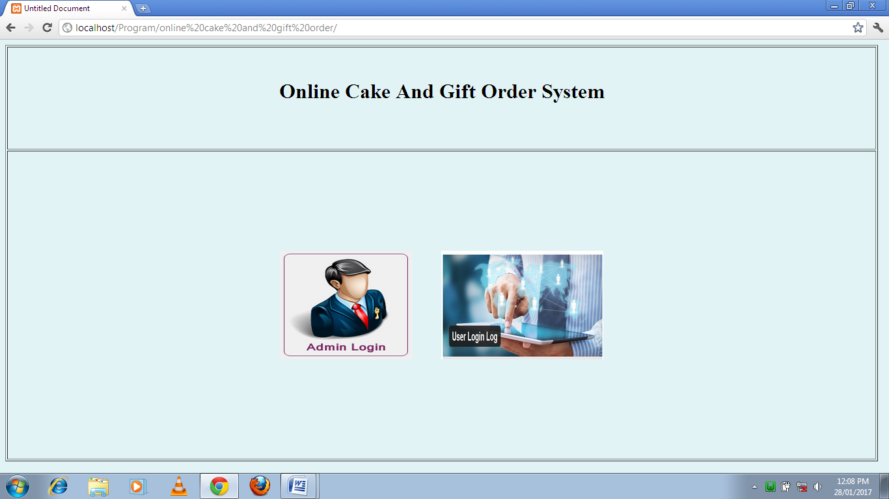

26

User Registration:-

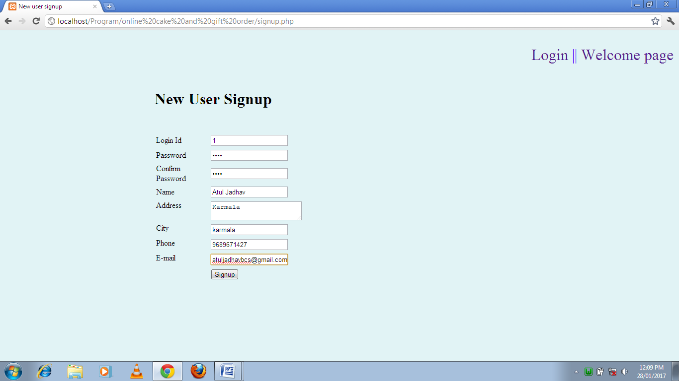

27

User Login Page:-

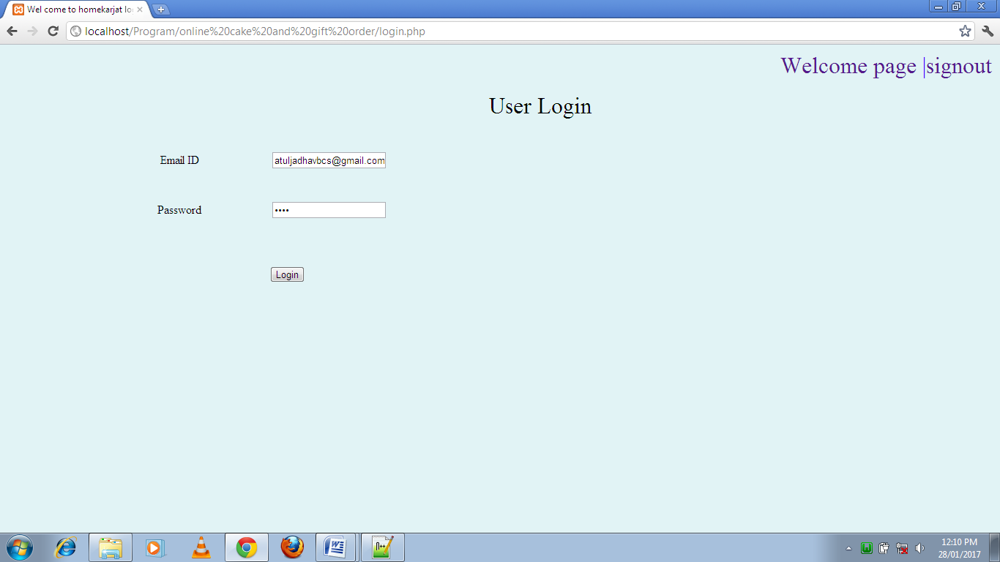

28

User Login Successfully:-

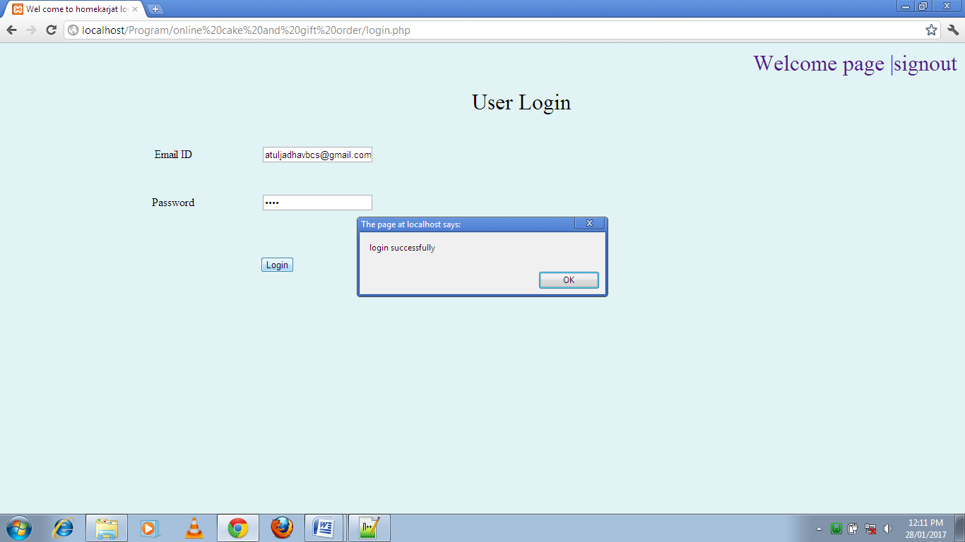

29

Home Page:-

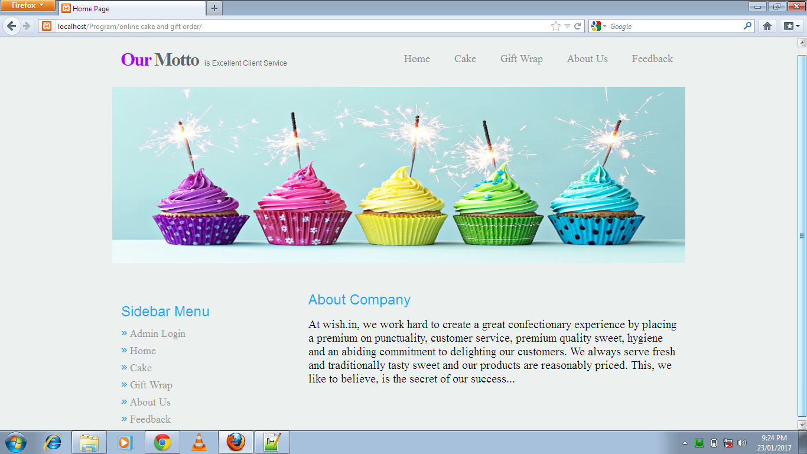

30

Buy cake form:-

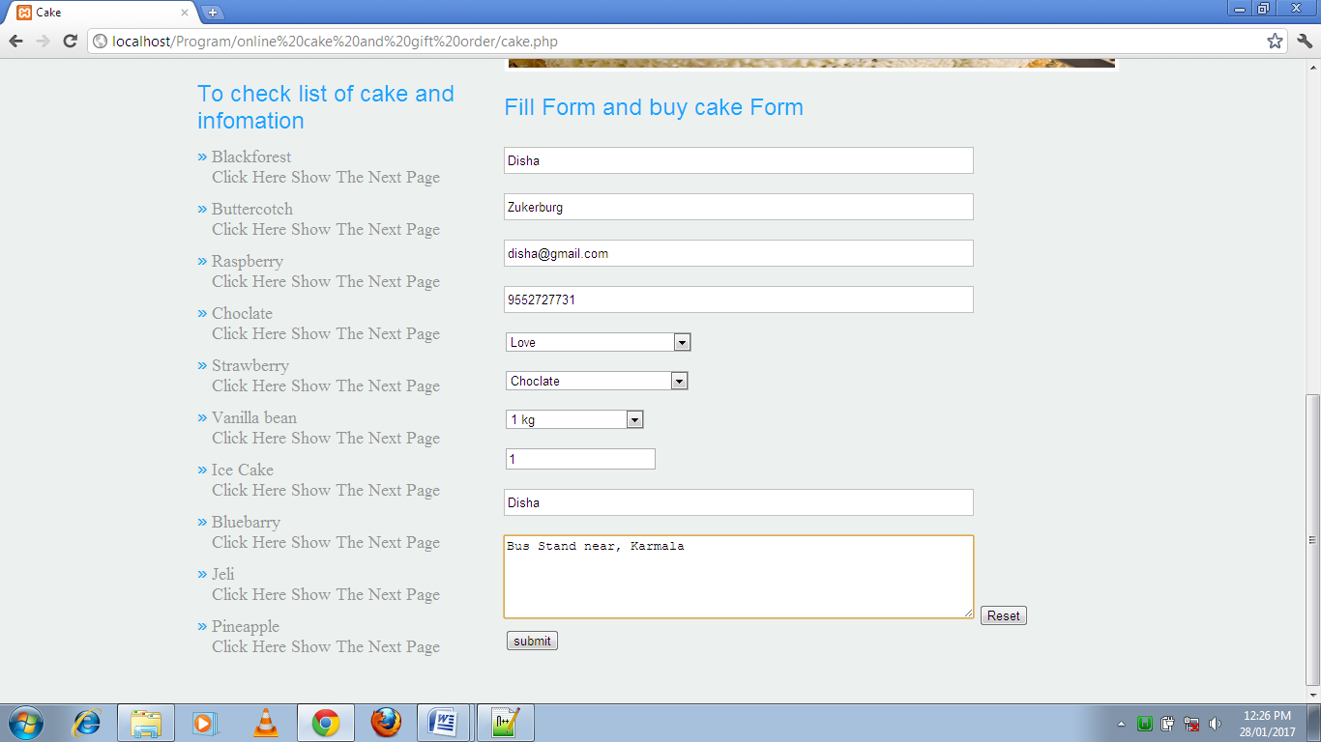

31

Buy gift form:-

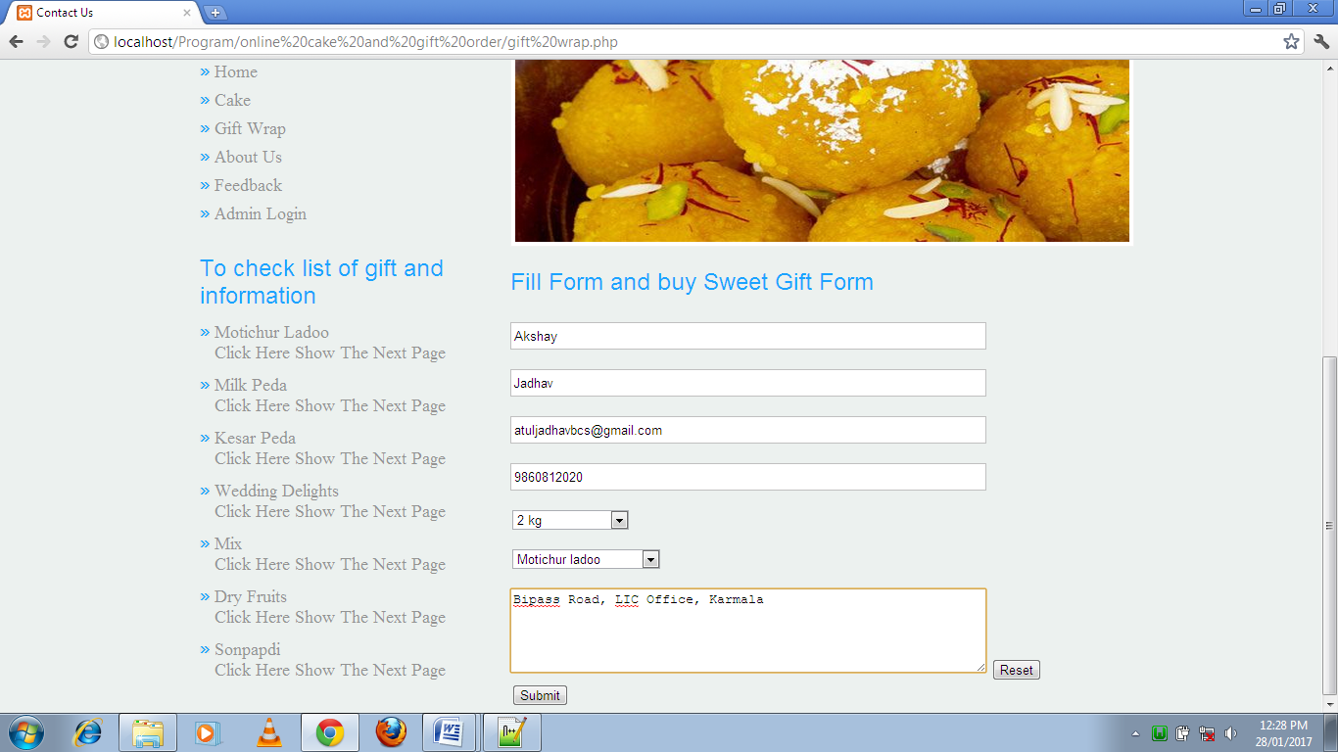

32

Admin Login:-

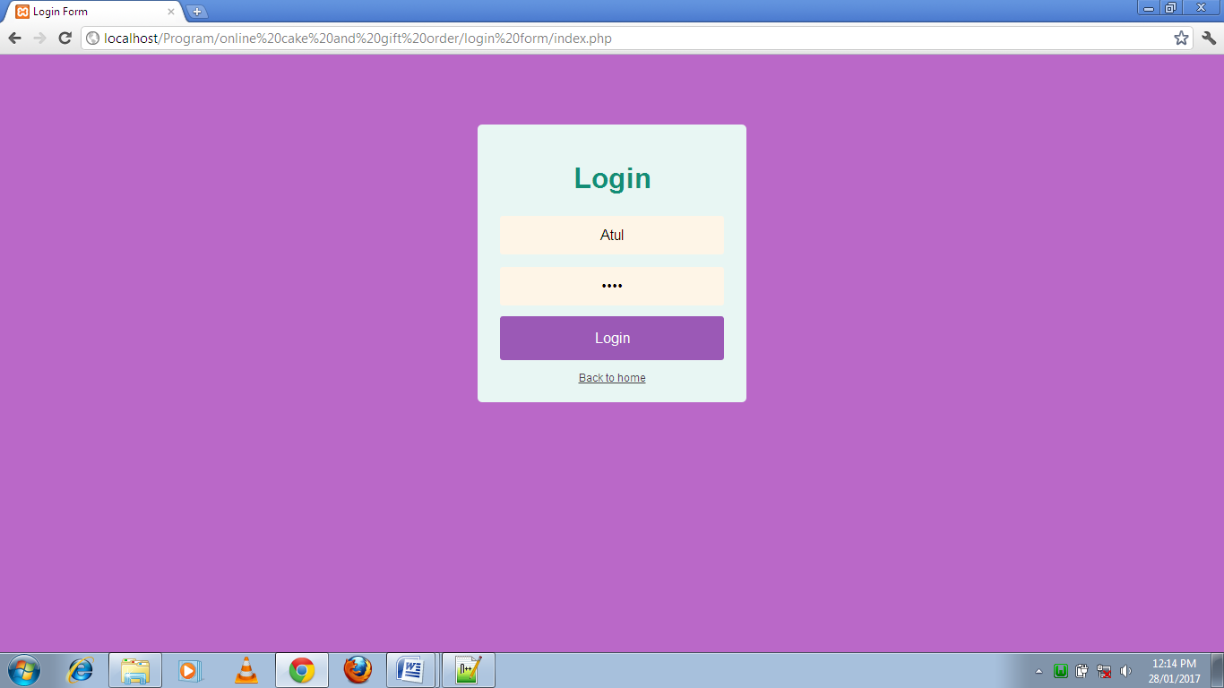

33

Home Page of Admin:-

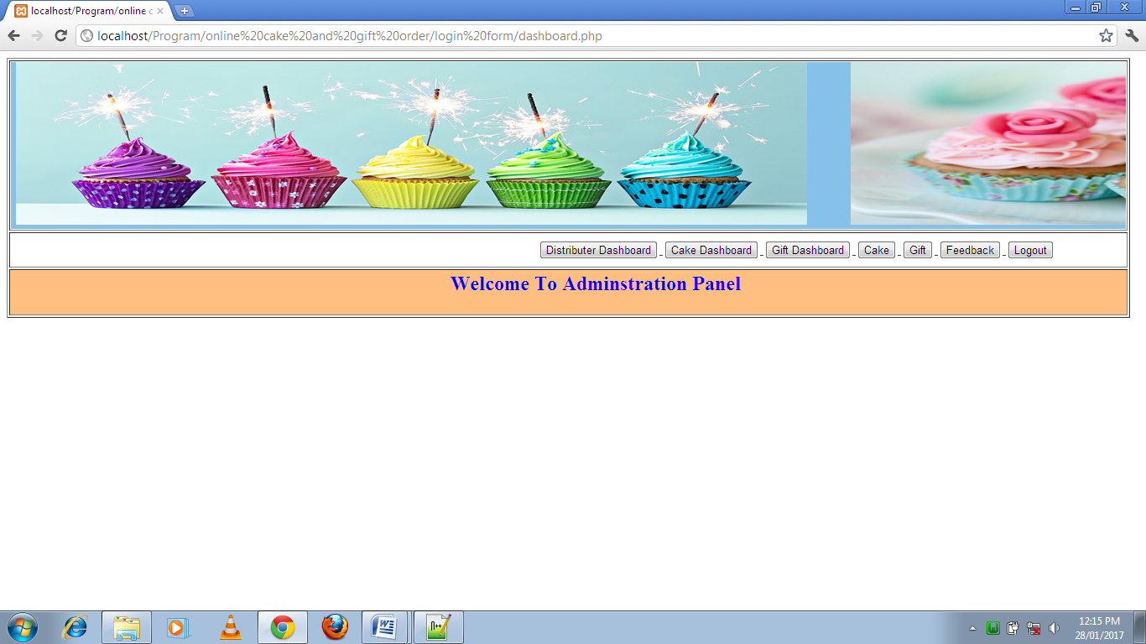

34

List of the buy cake user:-

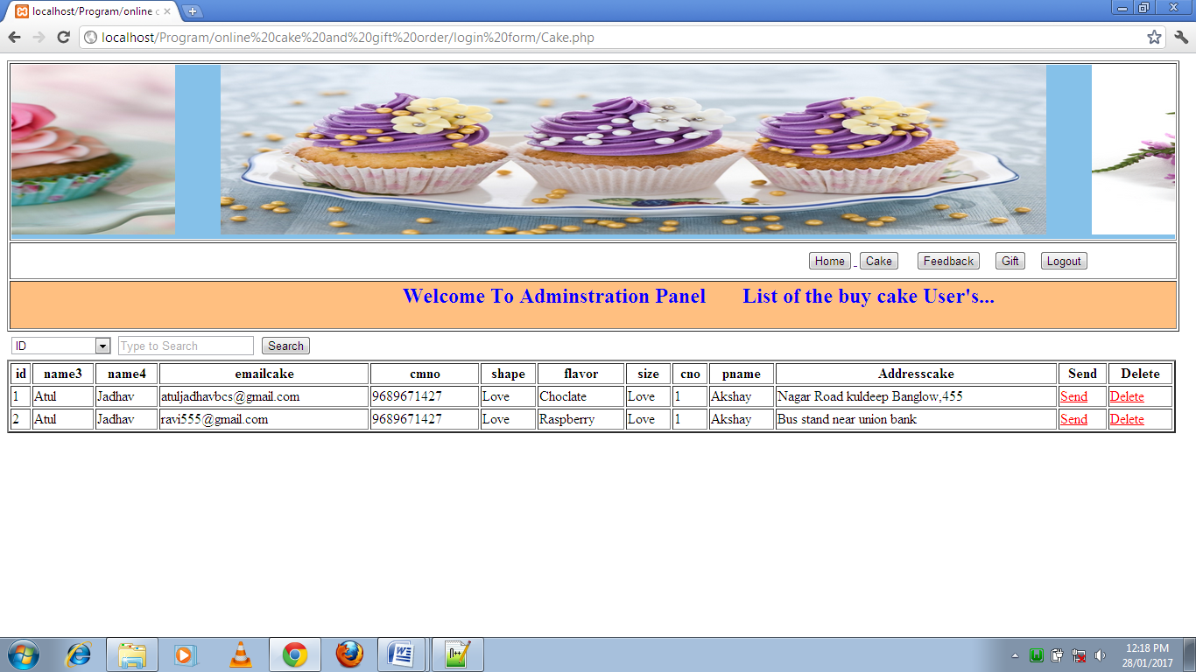

35

List of the buy gift user:-

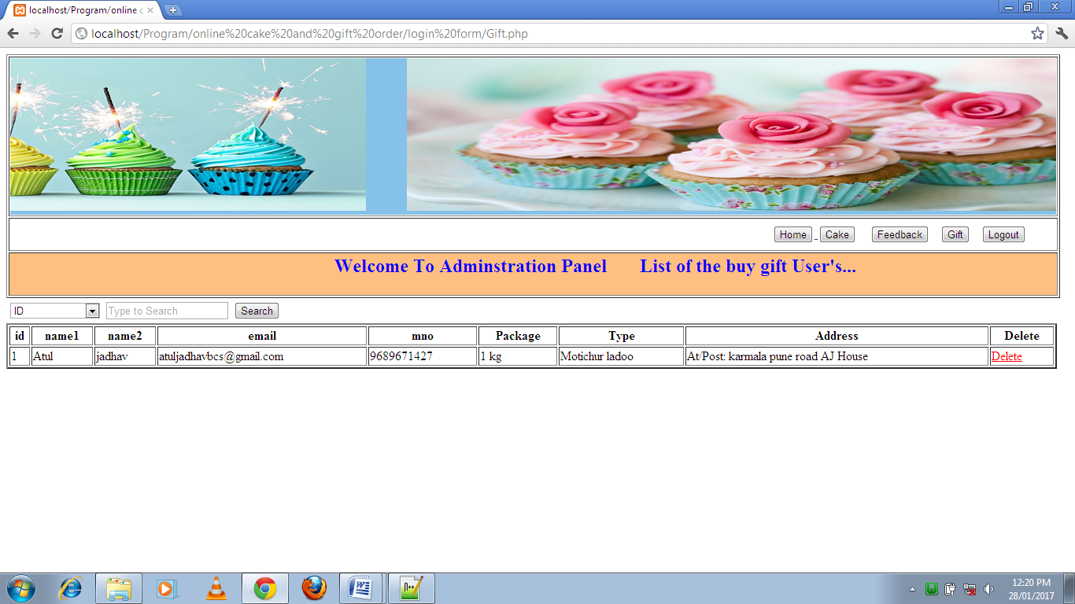

36

Feedback of user:-

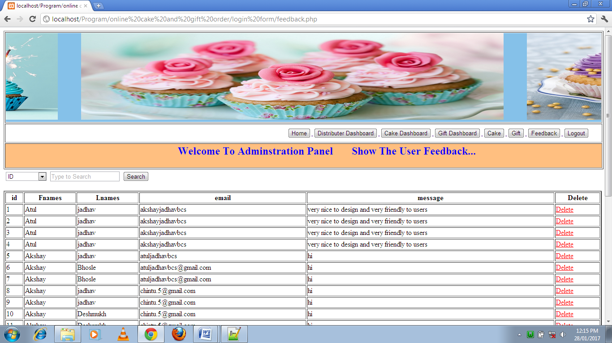

37

Search result of feedback:-

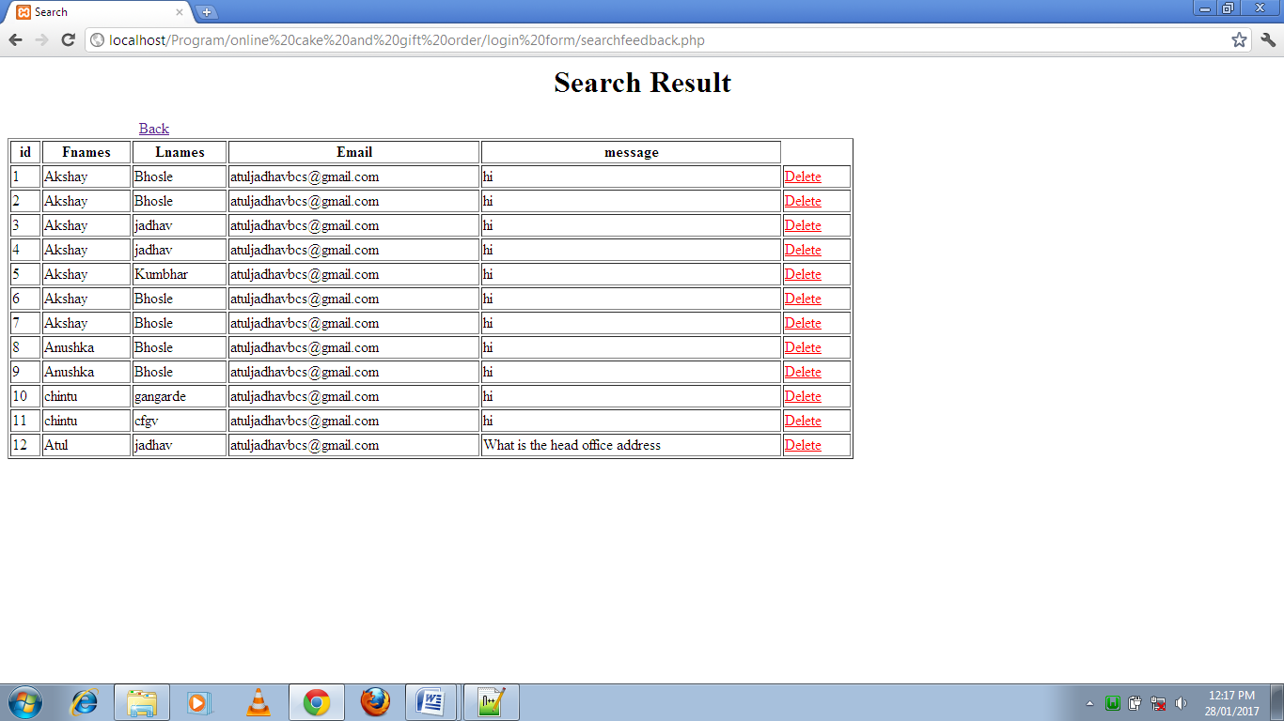

38

Cake dashboard:-

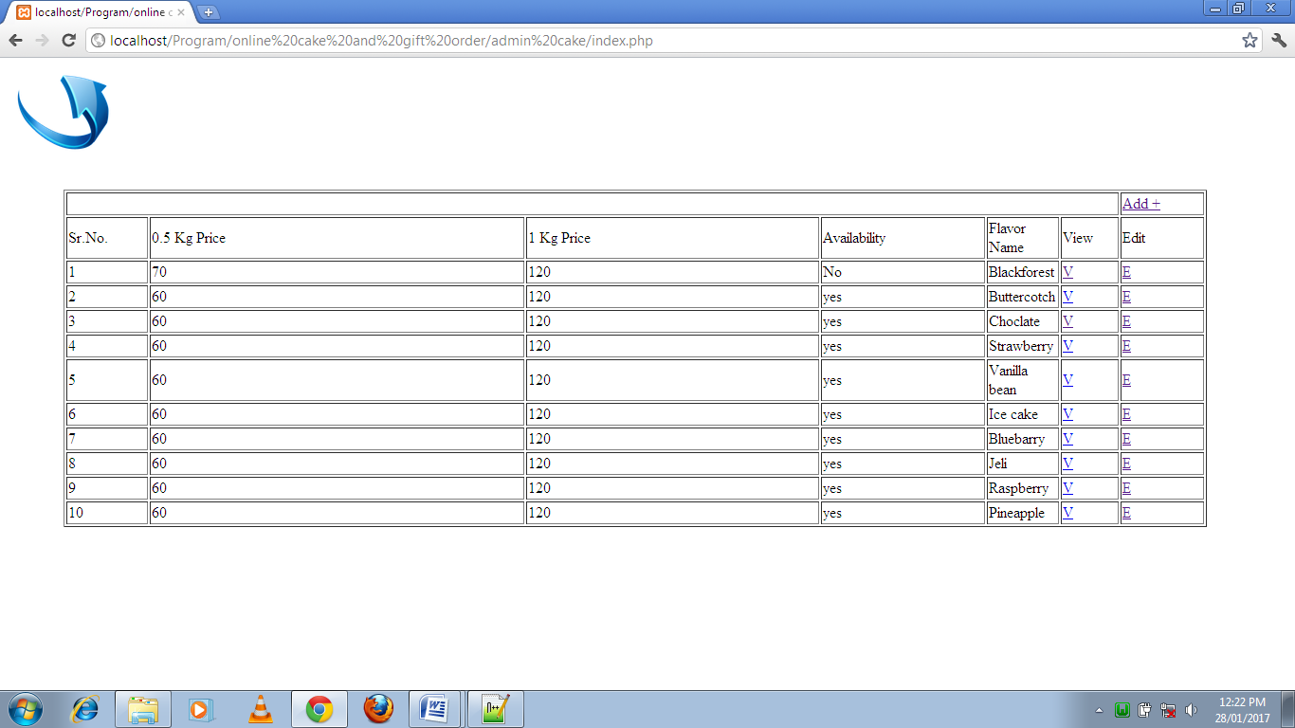

39

Gift dashboard:-

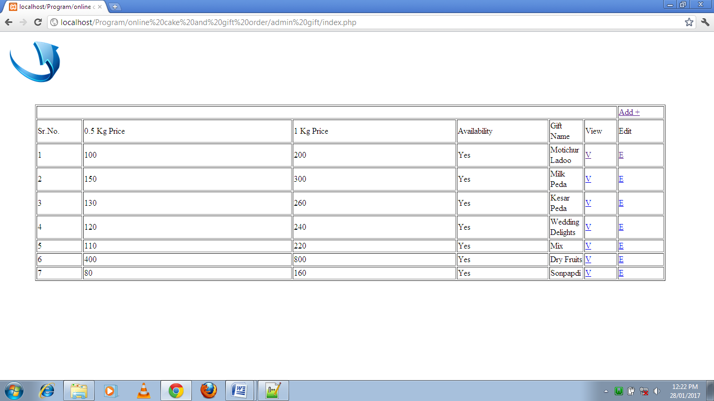

40

Distributer dashboard:-

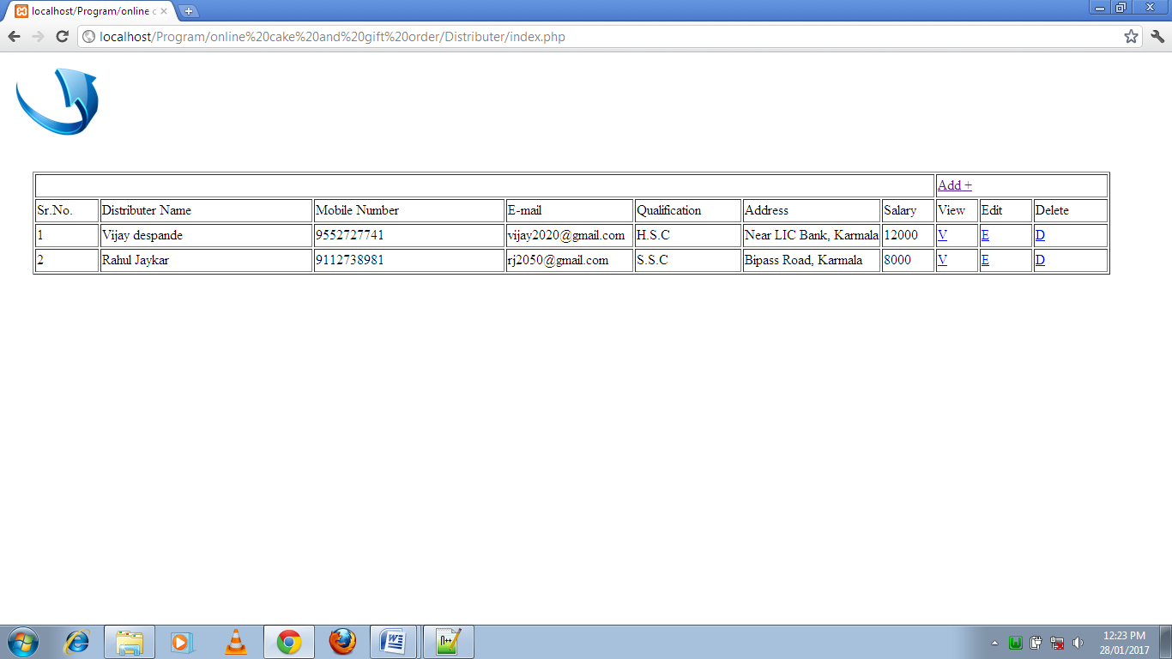

41

Cake flavor:-

1. Blackforest:-

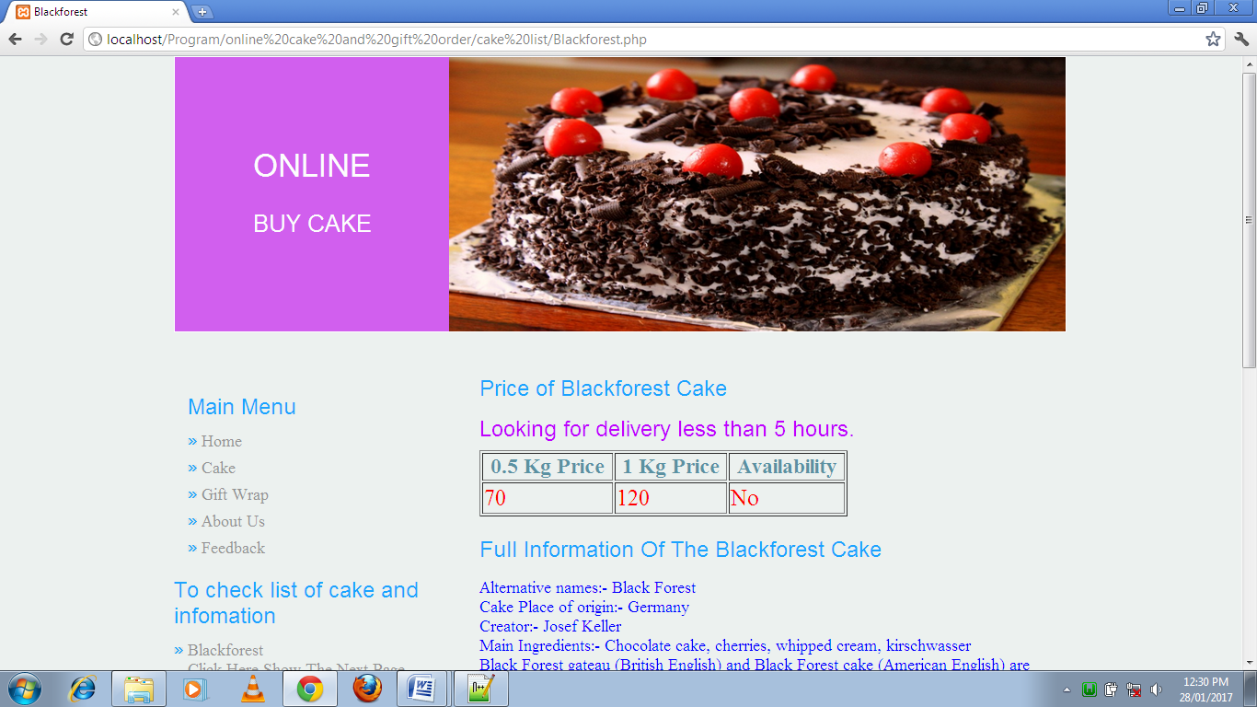

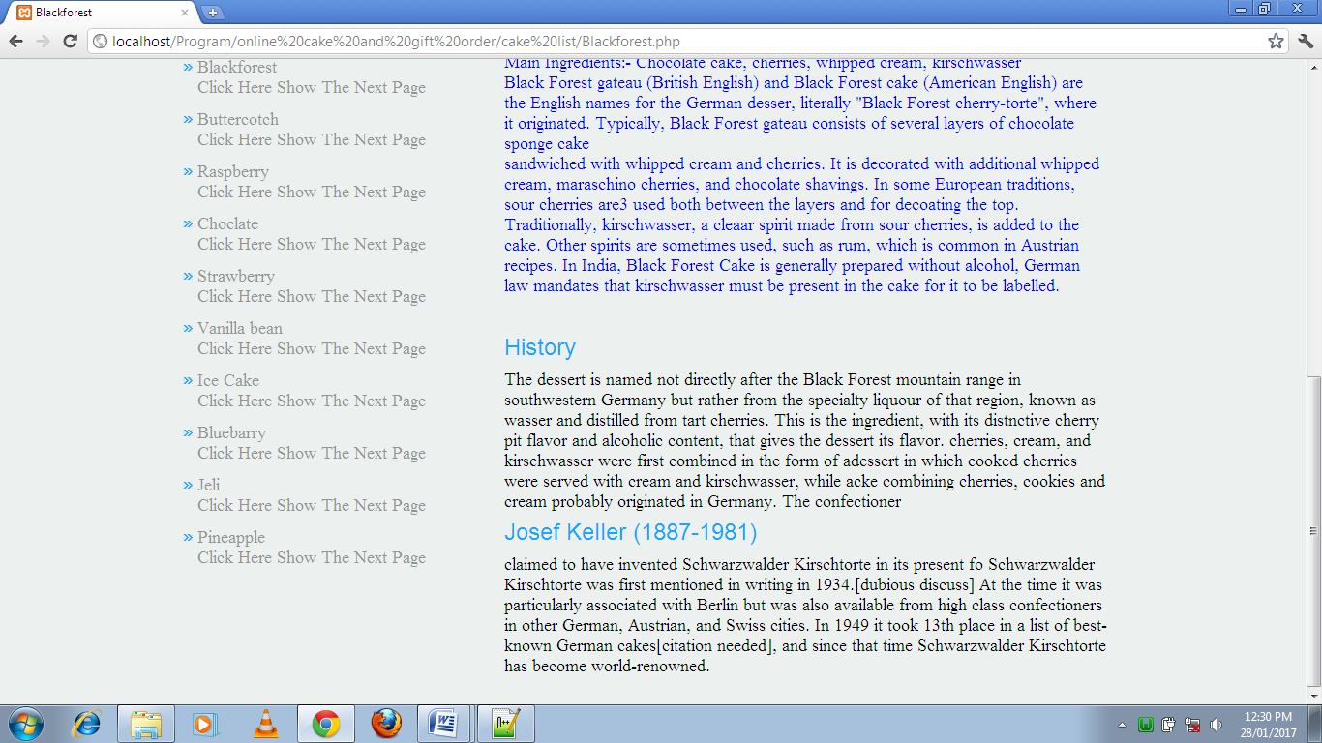

42

1. Rashberry:-

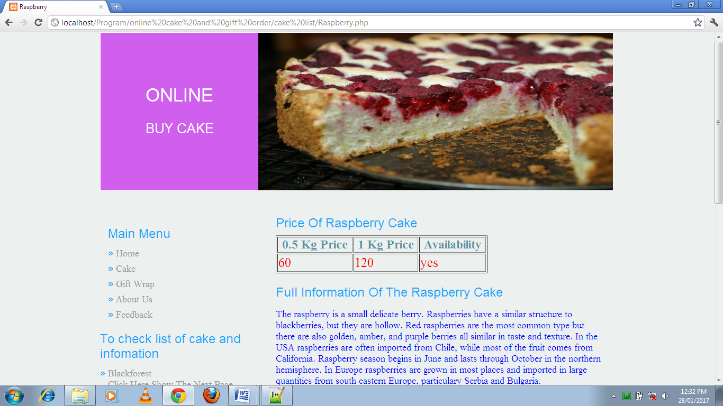

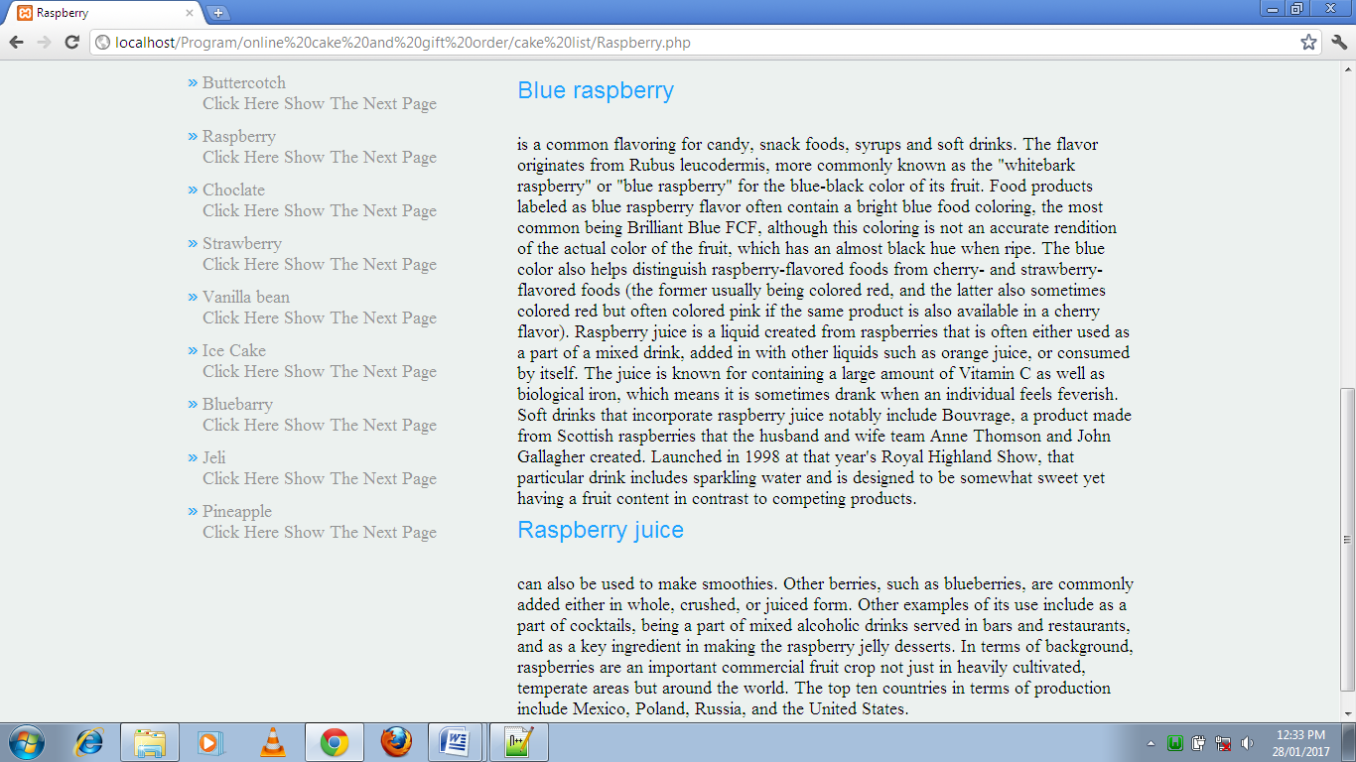

43

1. Chocolate:-

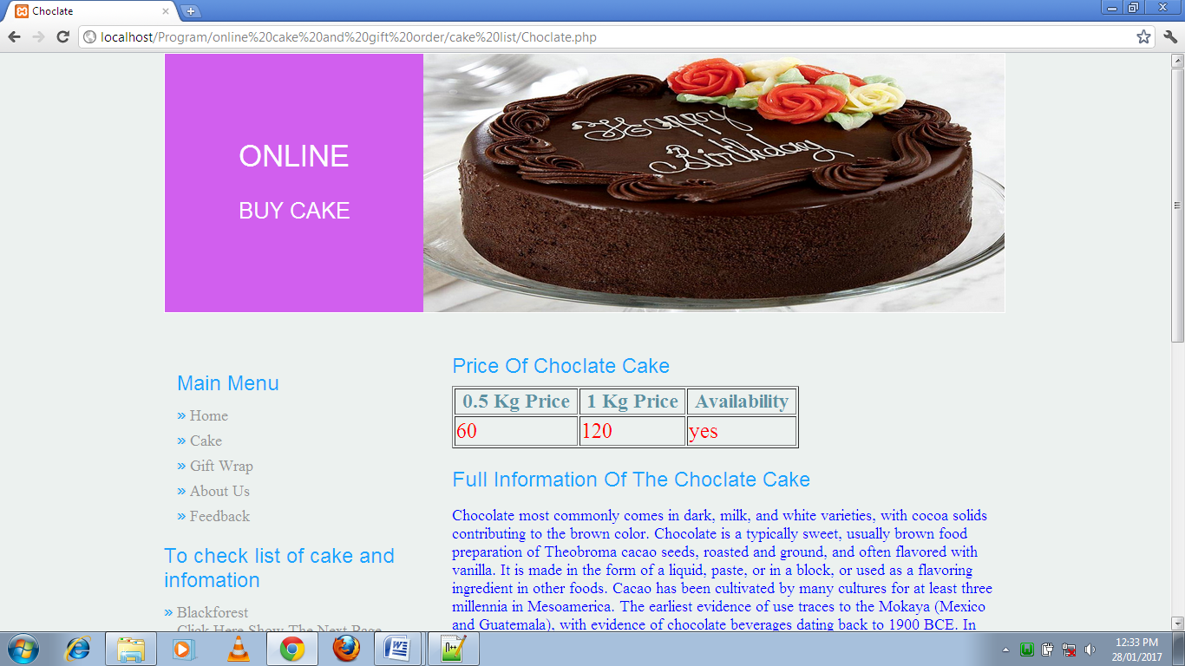

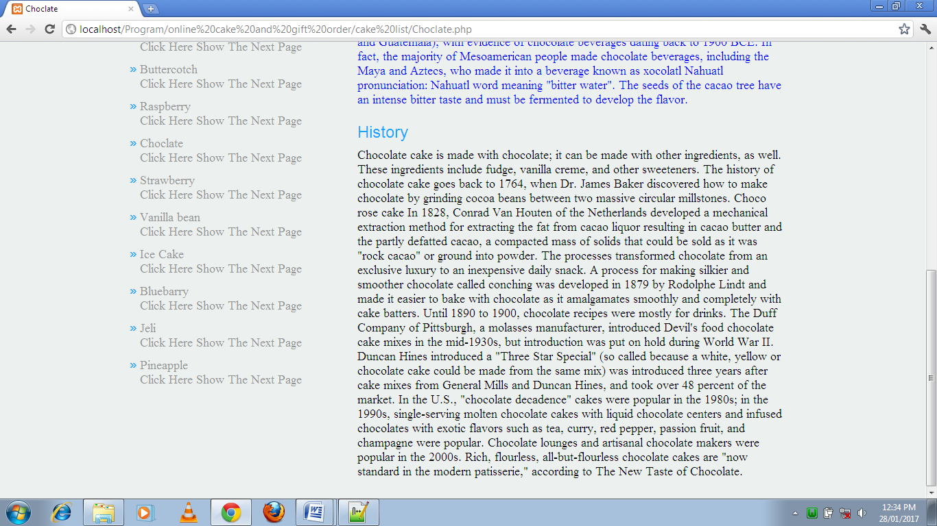

44

1. Strawberry:-

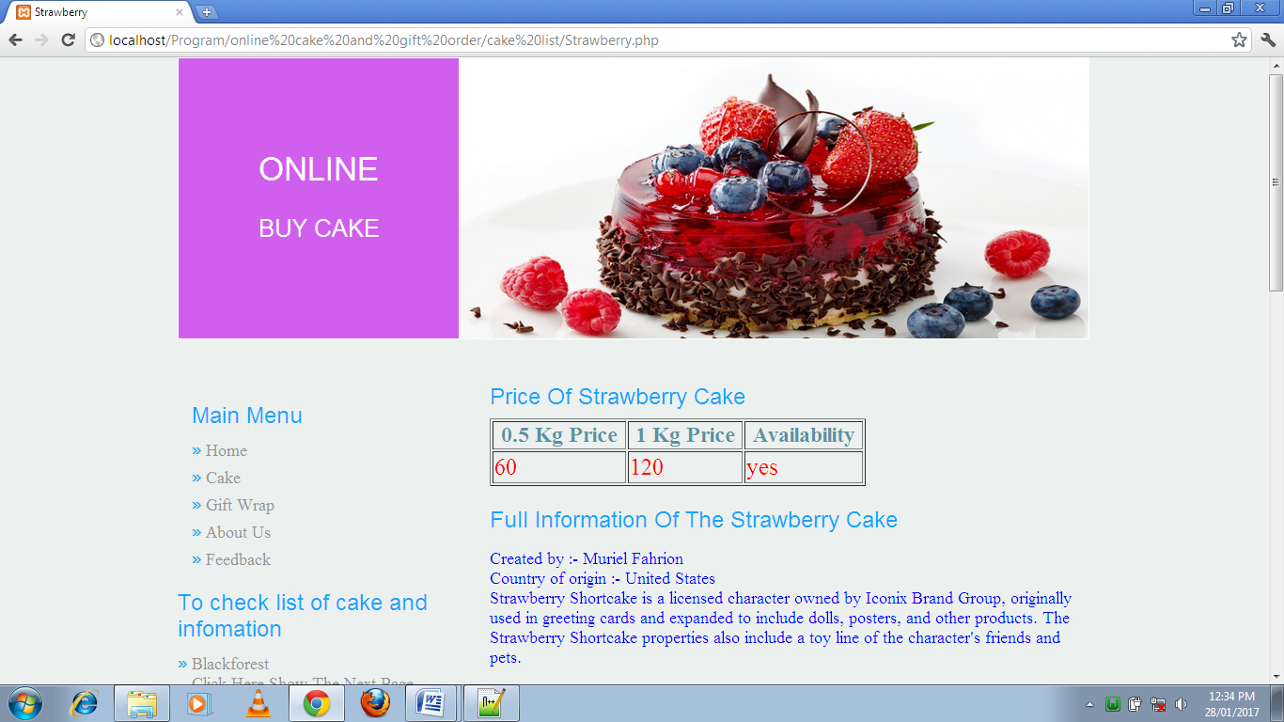

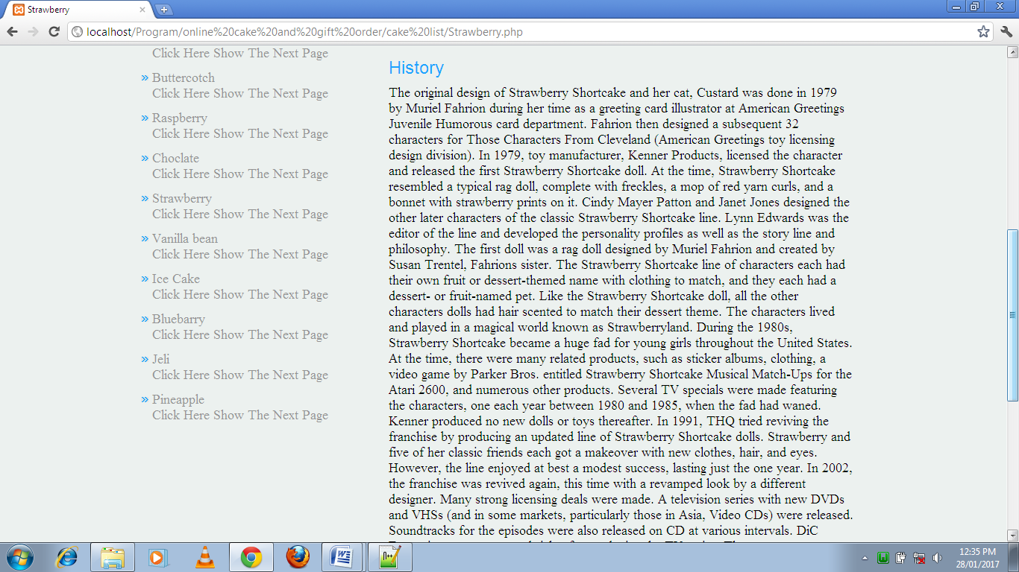

45

1. Jeli:-

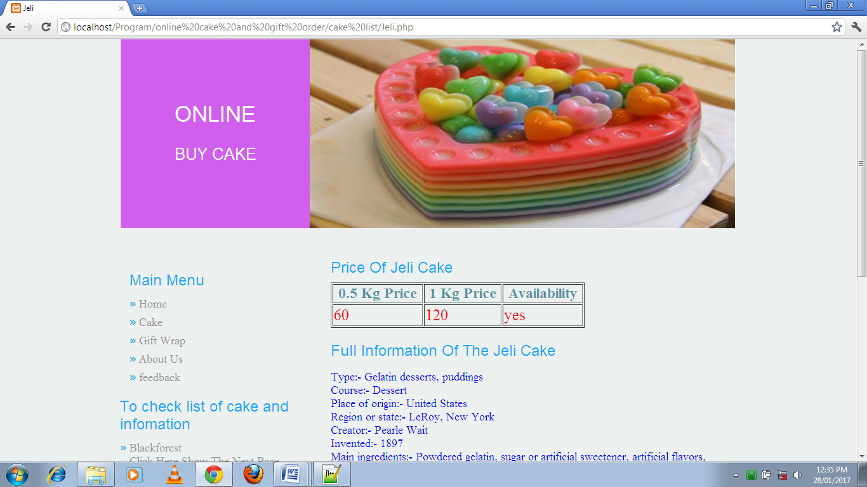

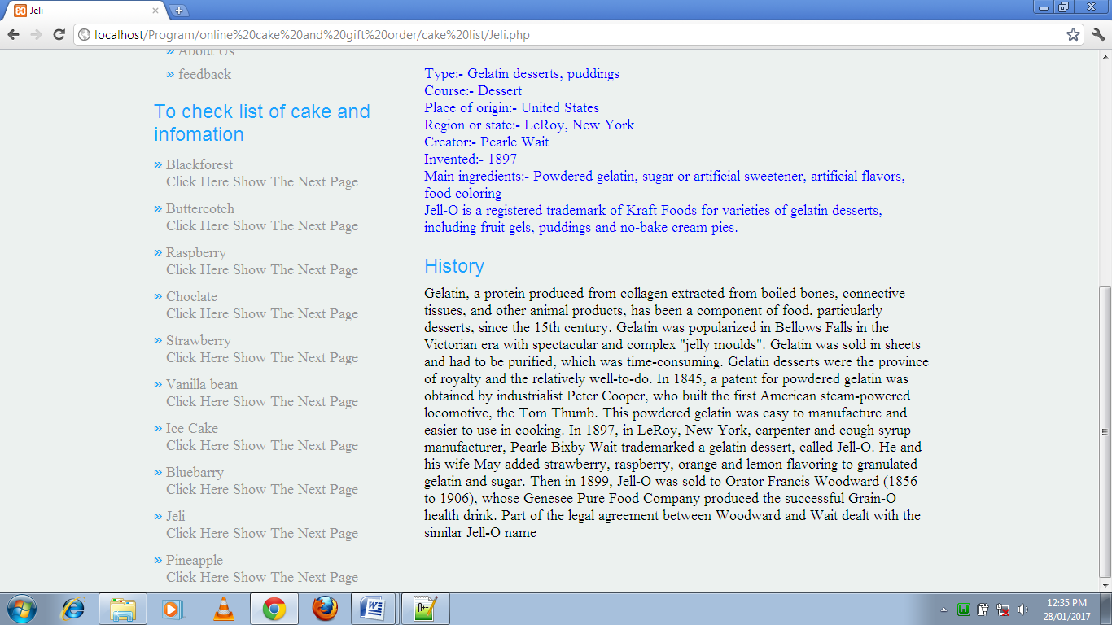

46

Search Result of Cake:-

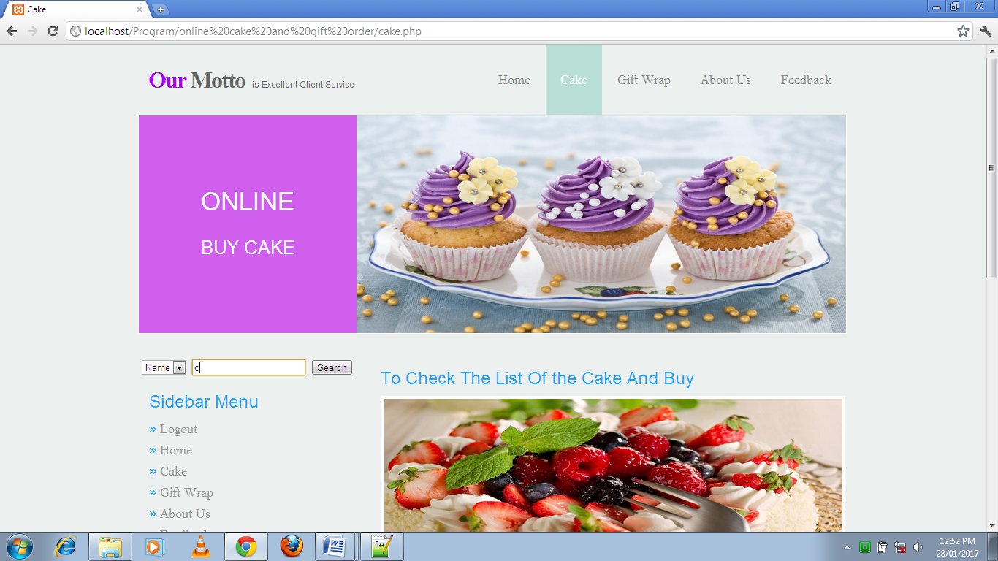

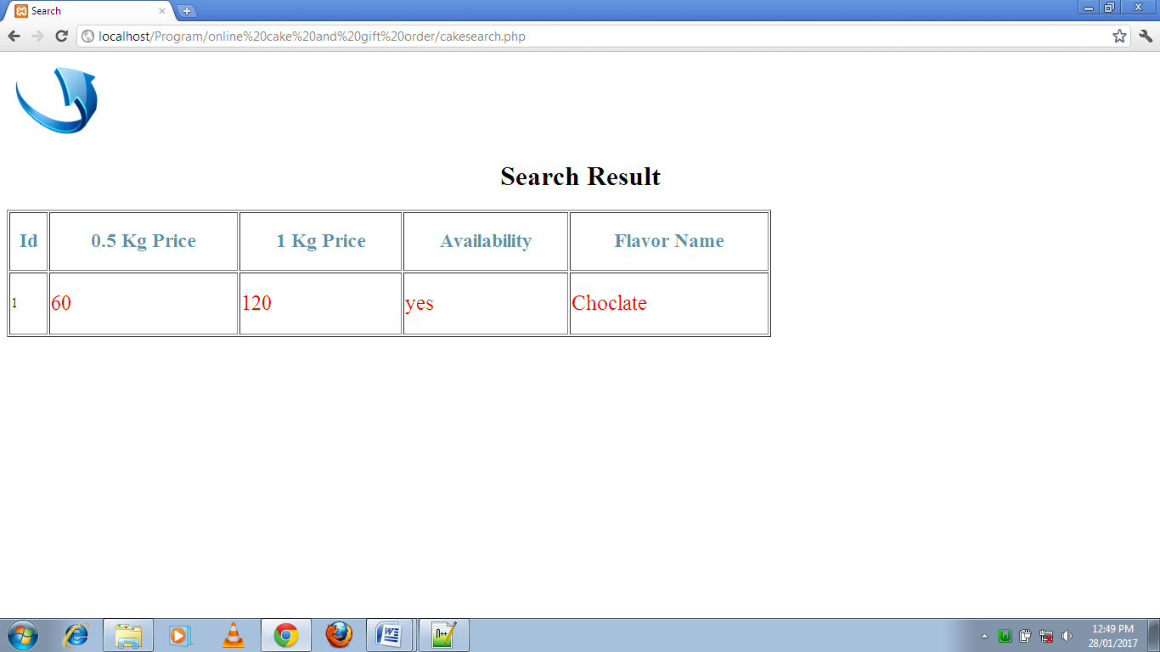

47

Sweat gift flavor:-

1. Motichur Ladoo:-

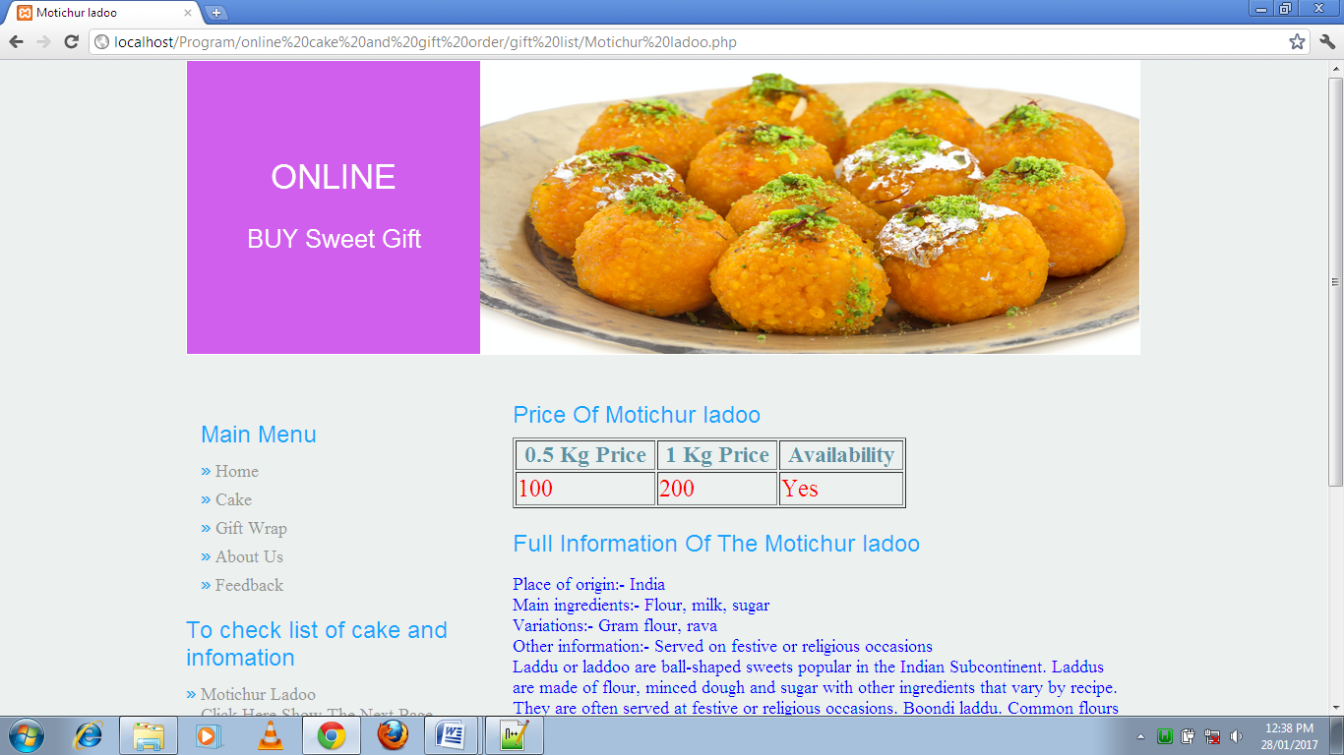

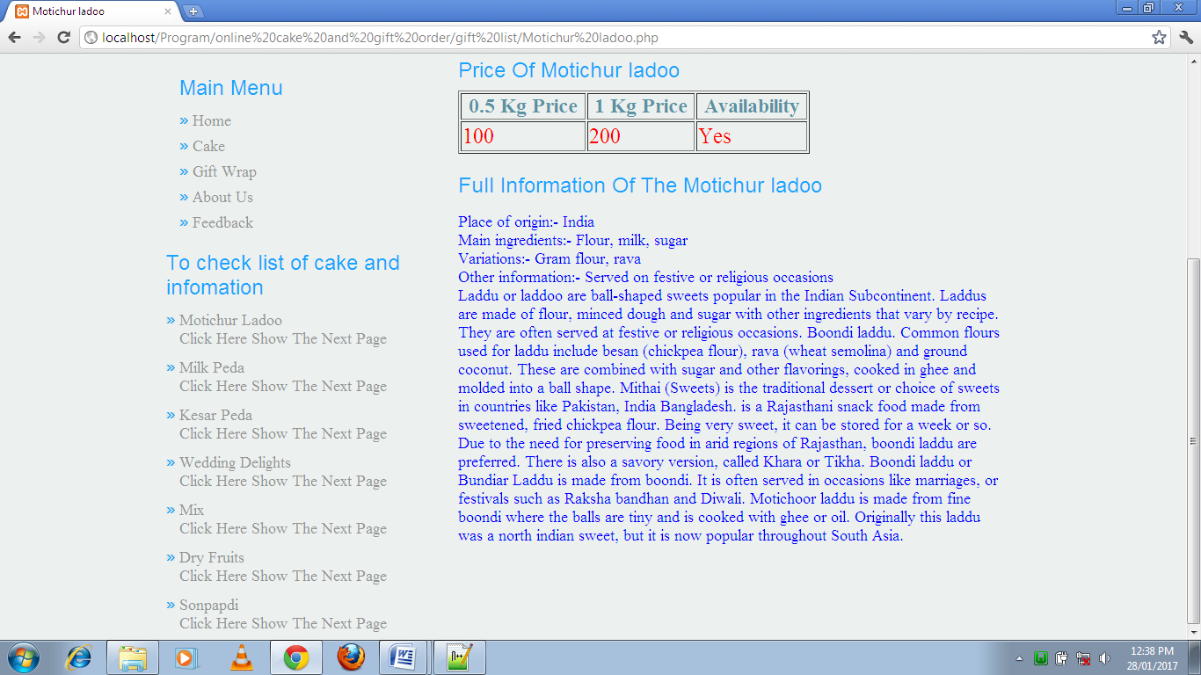

48

1. Milk peda:-

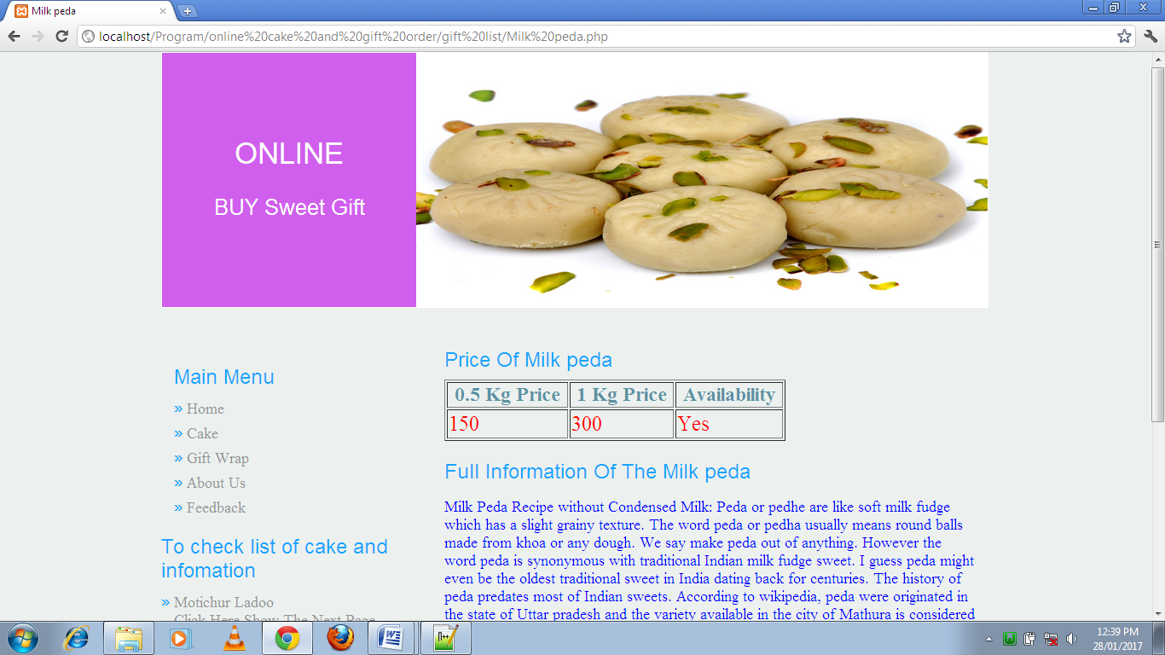

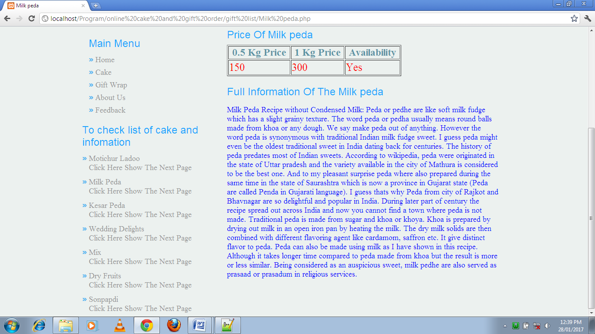

49

1. Kesar peda:-

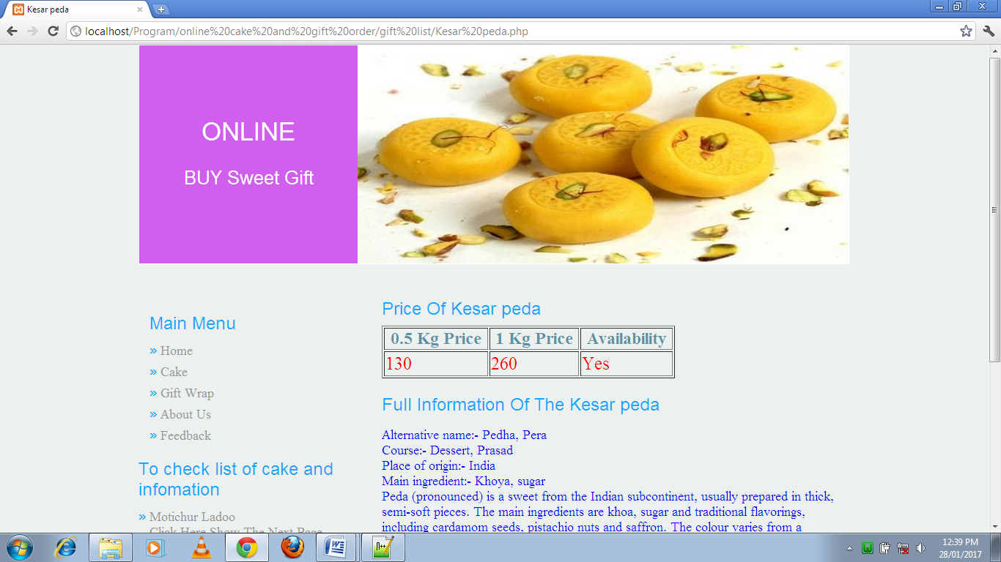

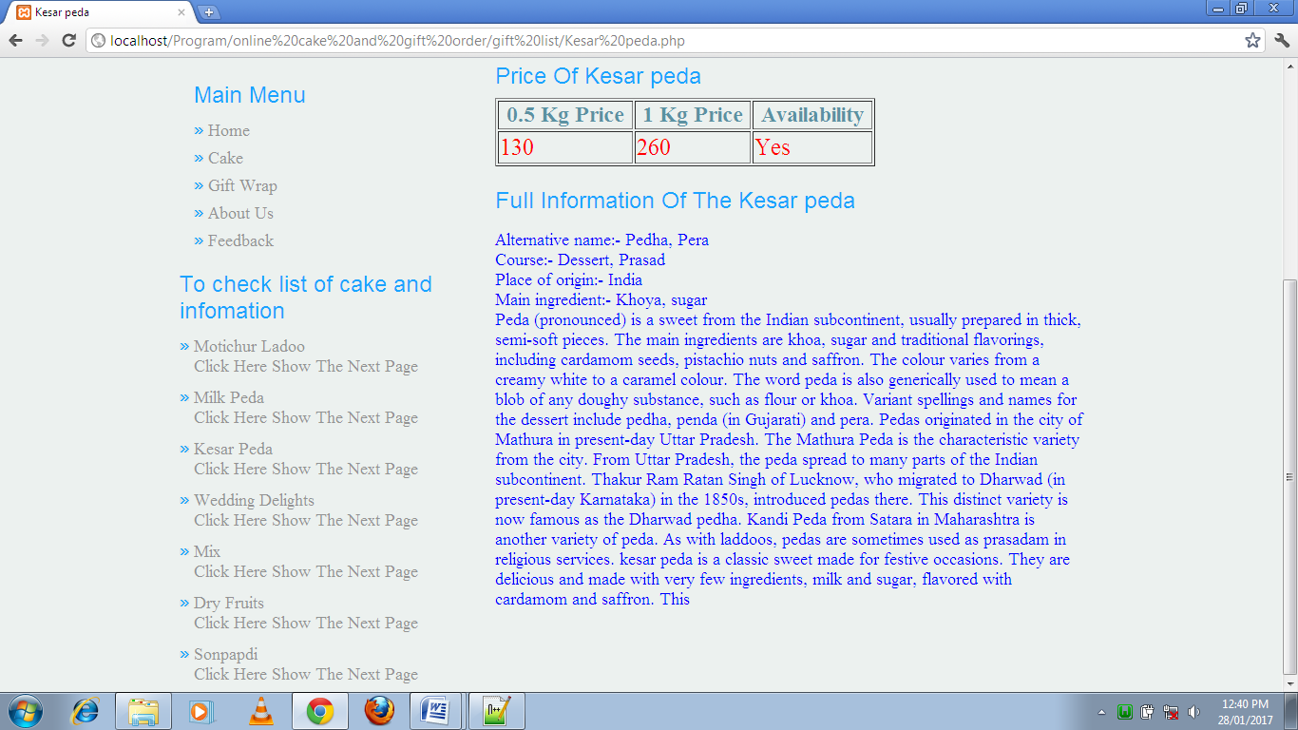

50

4) Wedding delights:-

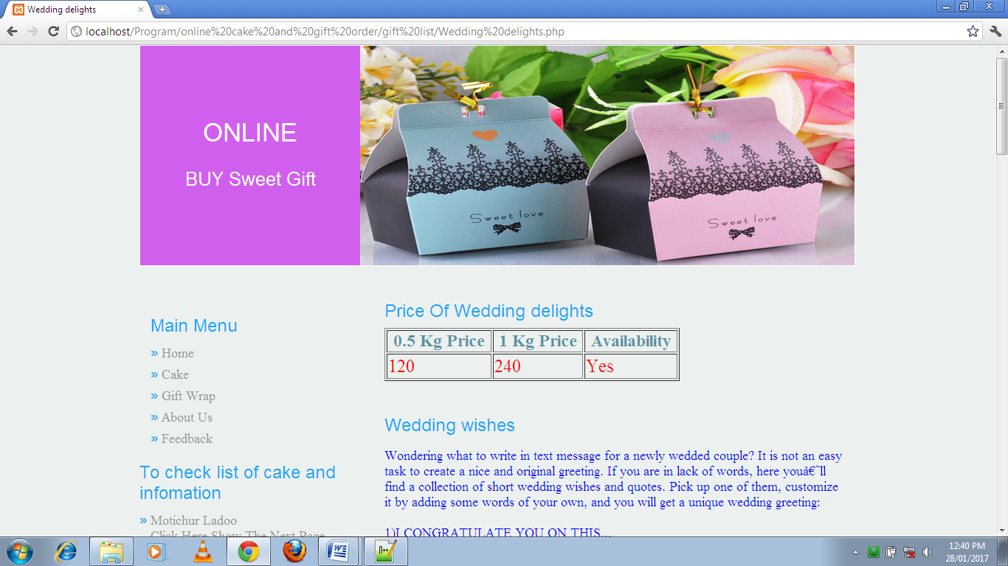

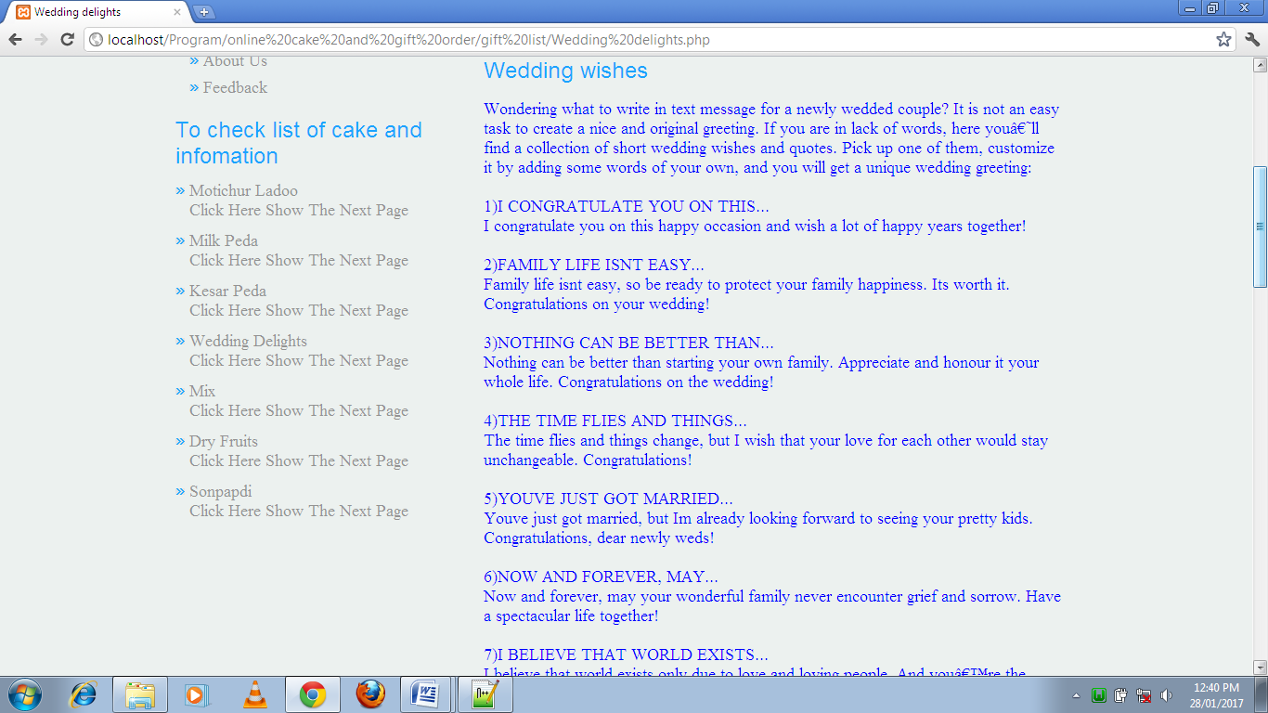

51

1. Dry fruits

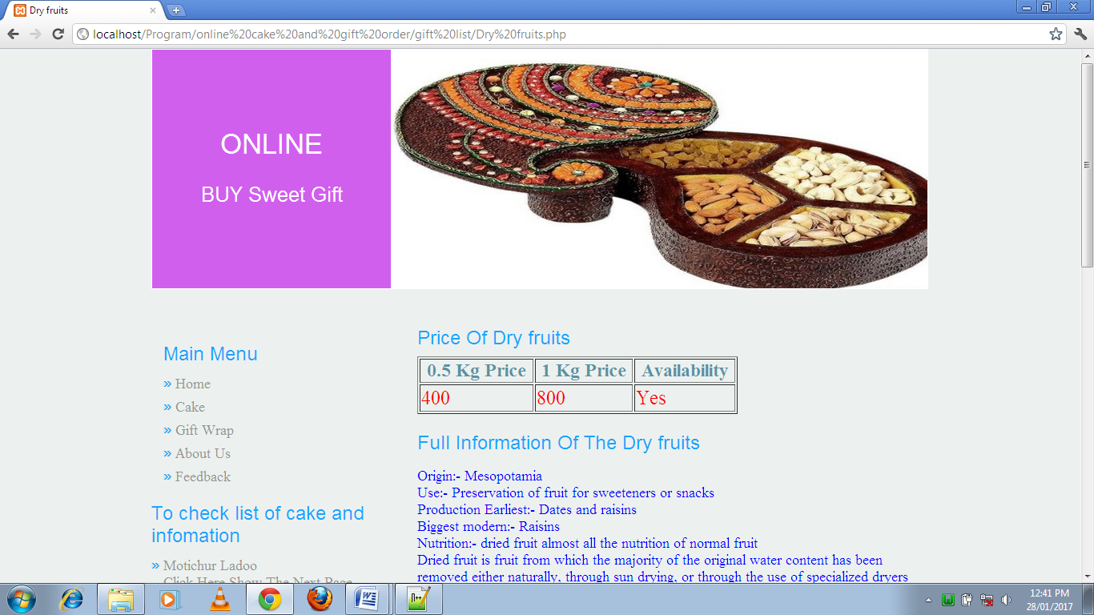

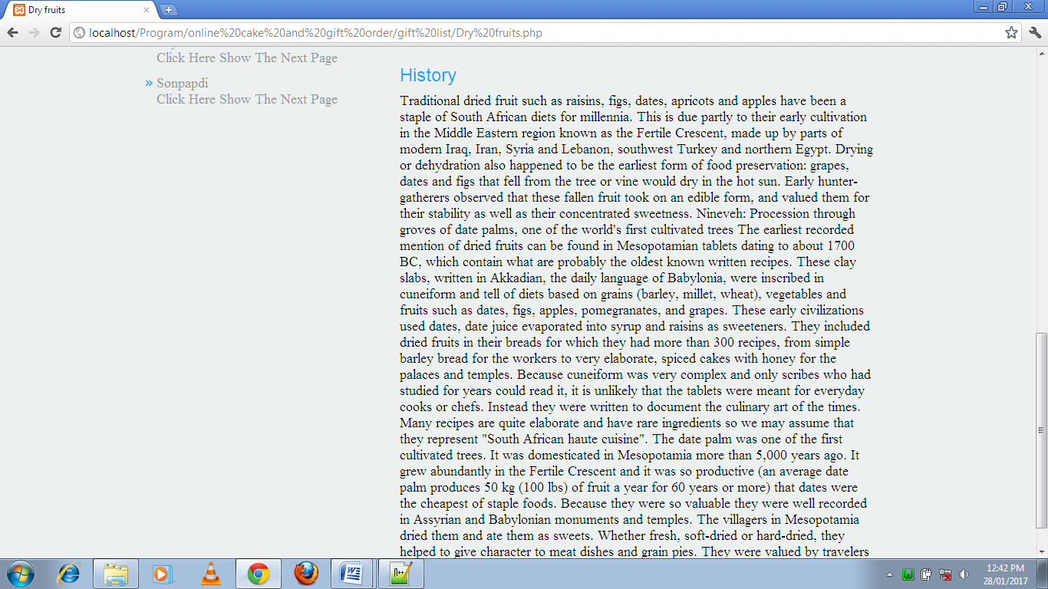

52

6)Sonpapdi:-

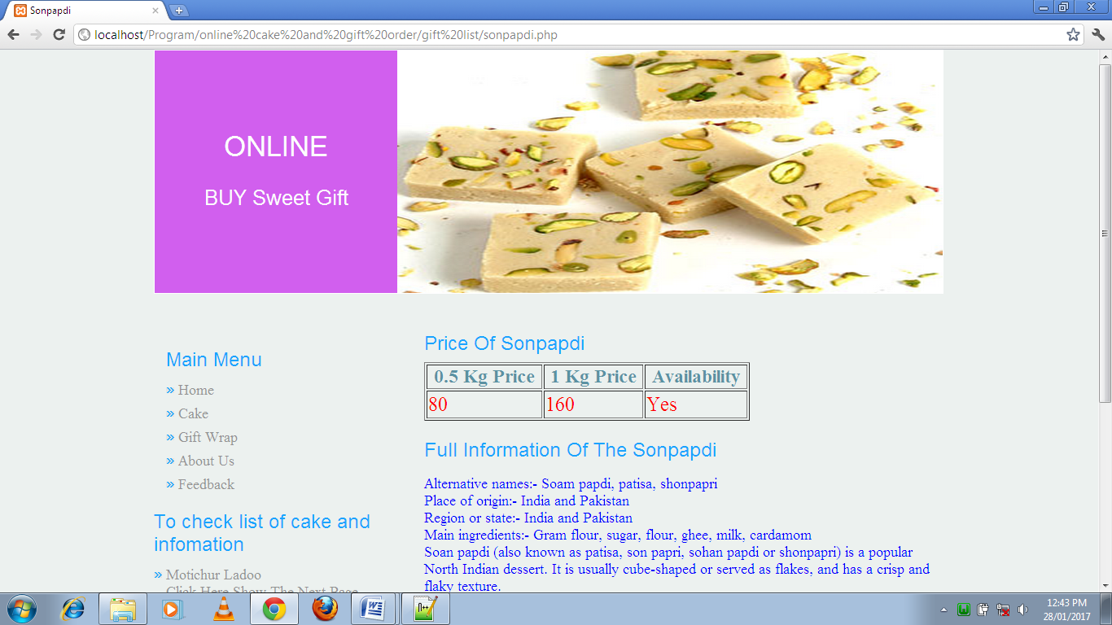

53

Search Result of Gift:-

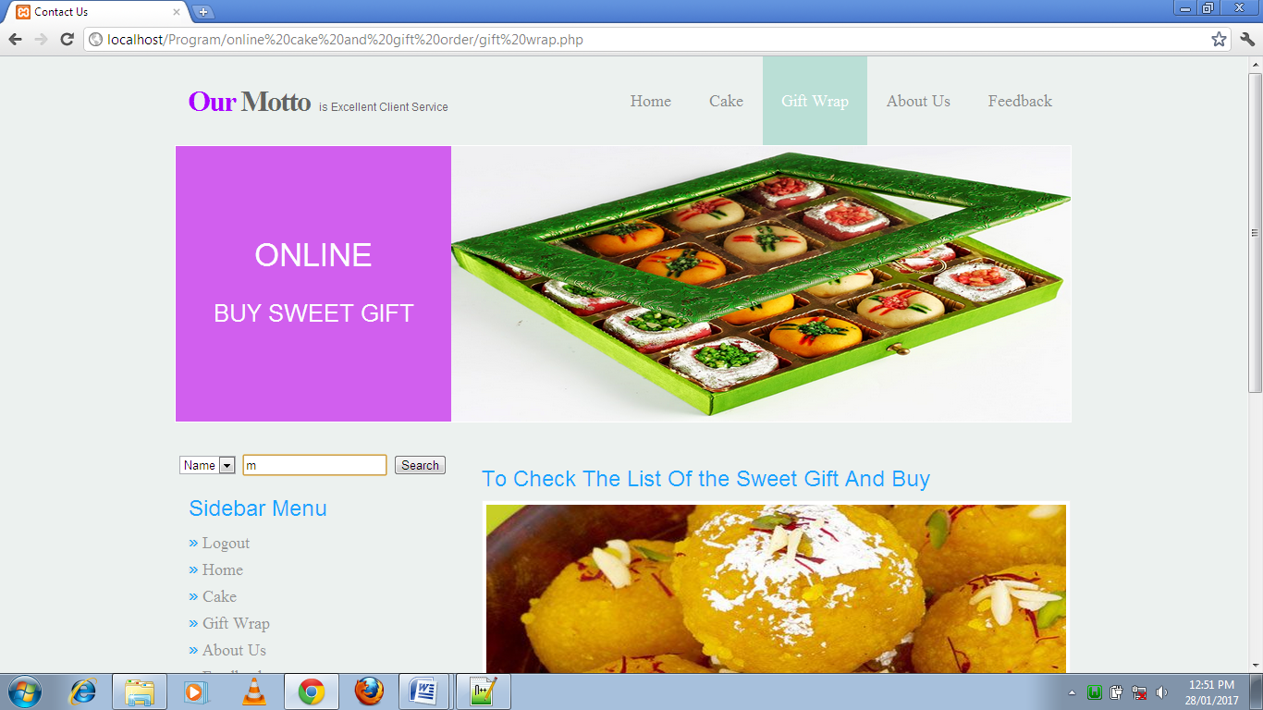

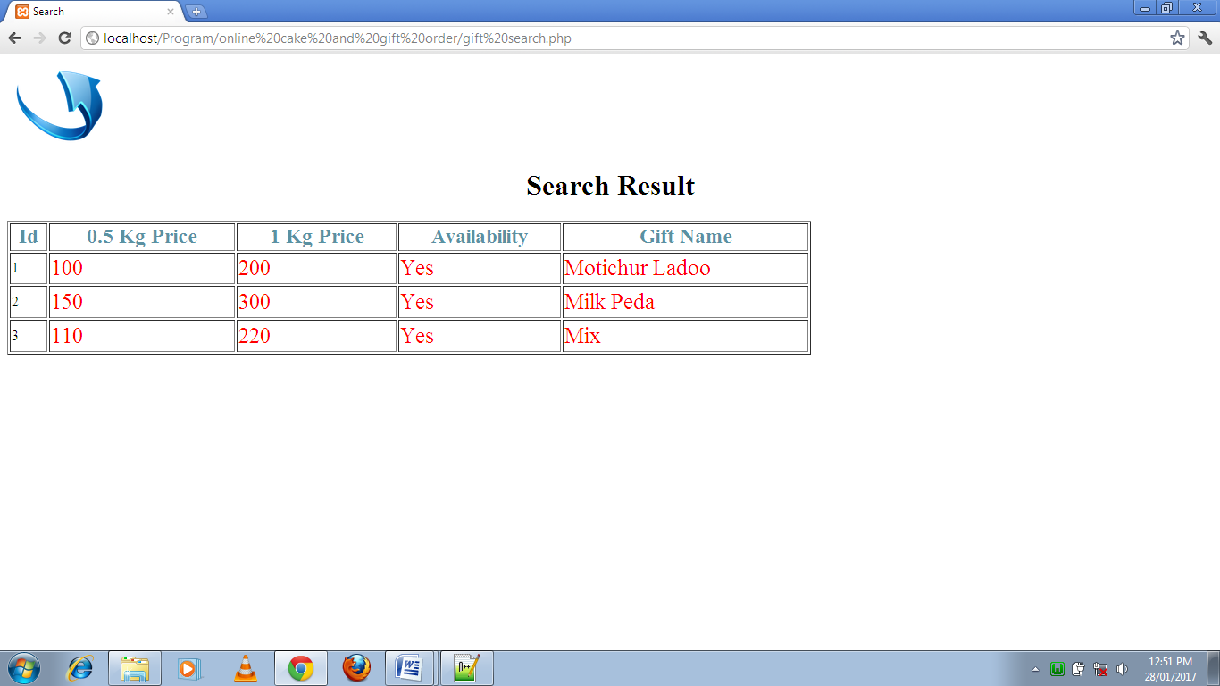

54

About Us:-

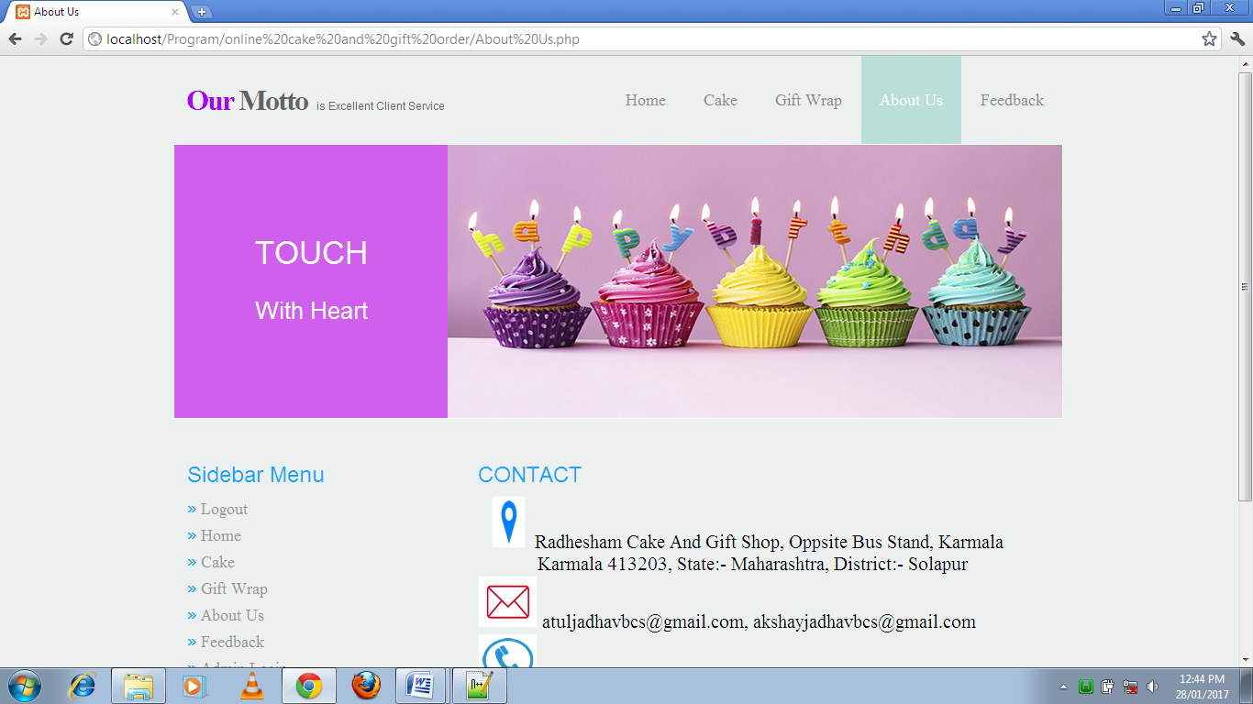

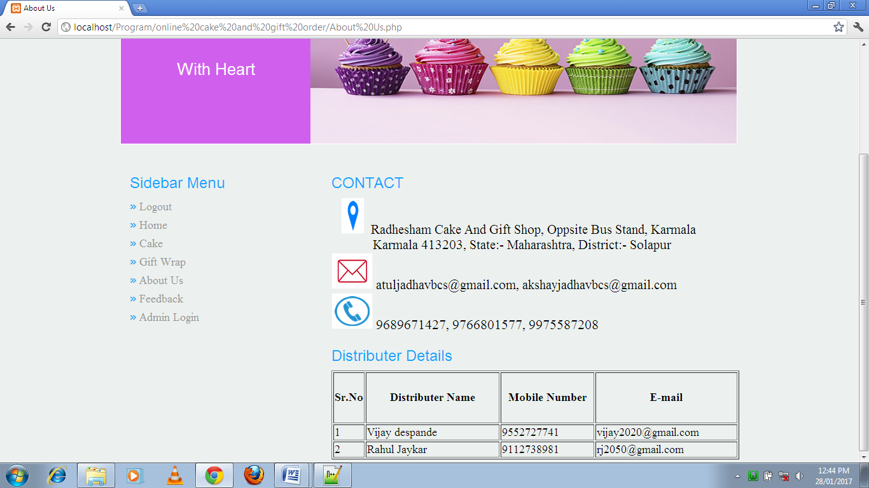

55

Feedback:-

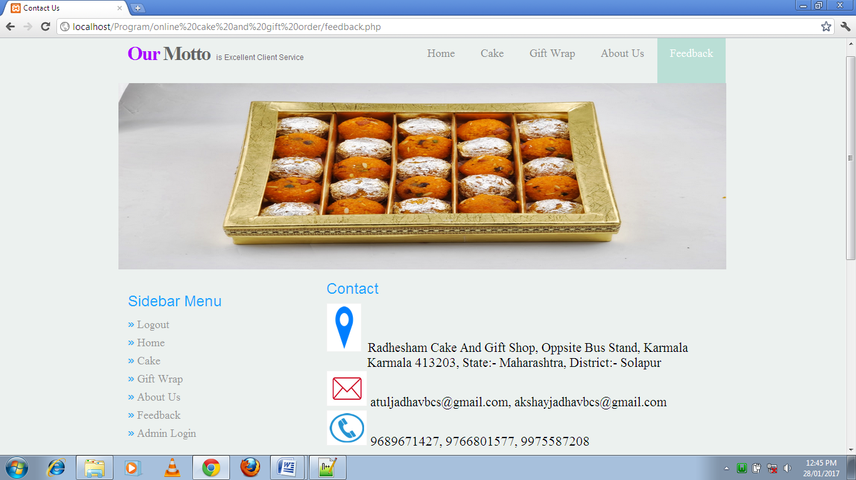

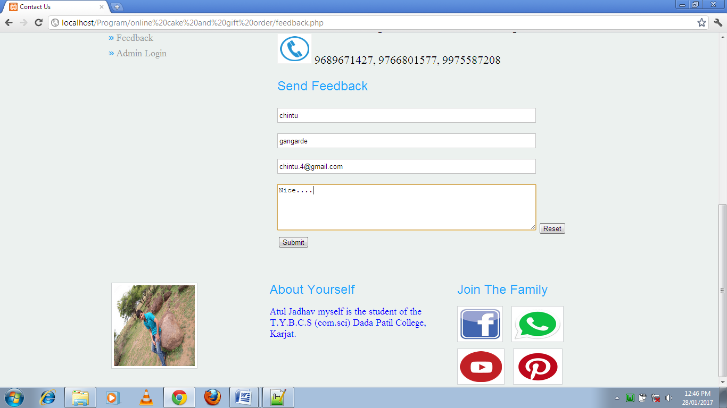

56

***4) LIMITATION:-***

* It is useful to only small/big city.
* Our system is not work for some Amazon, Flipkart so on.

57

***5) FEATURE ENHANCEMENT:-***

* We are try to make system for online payment.
* We are try to Admin add dynamic cake and gift flavor pages of website.
* We are try to the totally dynamic website.

58

1. ***BIBLIOGRAPHY:-***

* Internet support for UML design.
* Microsoft E_Draw Software.
* The complete reference of PHP

-Mc Graw Hill Education

Steven Holzner

* PHP and MySQL

-Rasmus Lerdorf

Aruta Publishers

* www.w3 schools.com

-Website

* Internet Programming

-Tech-Max Publication

59